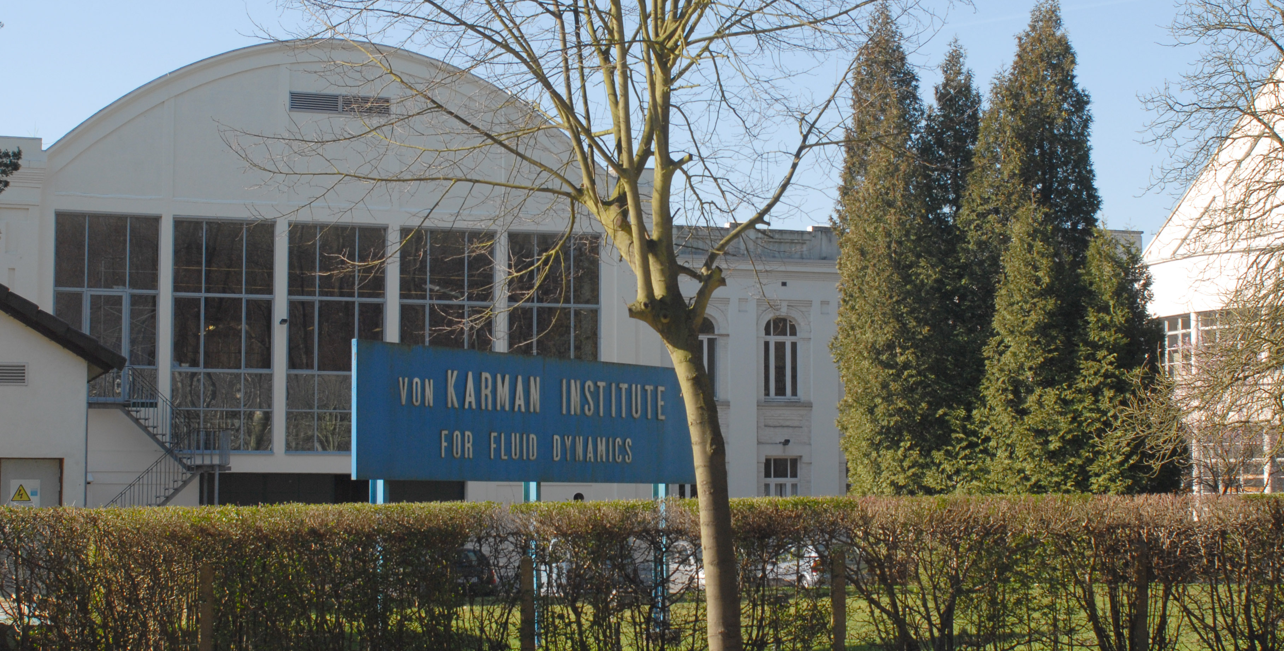
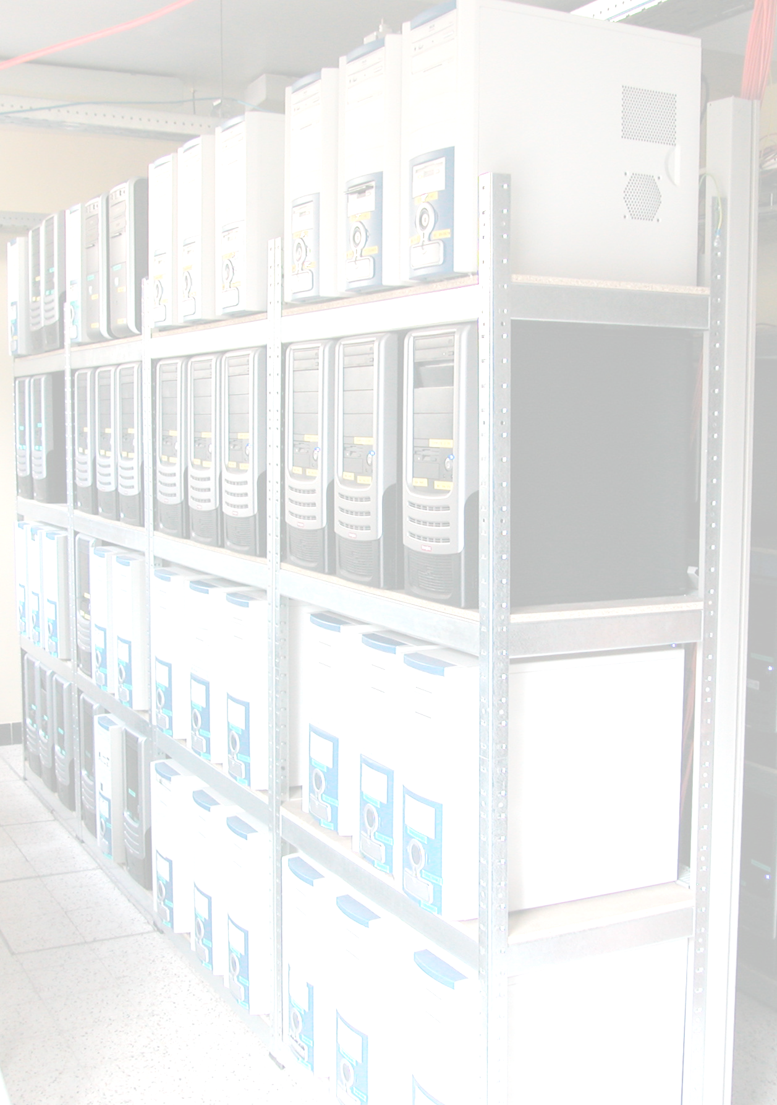

The von Karman Institute for Fluid Dynamics, a non-profit international educational and scientific organization, is looking for a System Administrator (bachelor) or System Engineer (master), m/f at the level of industrial masters or bachelor in informatics.

Function

You will be part of a team of professionals that handles a network of Linux Workstations and Windows PC's (over 100 in total), as well as multiple online collaboration services and different High Performance Clusters for scientific and engineering simulations (around 1000 cores in total).

Depending on your capabilities and performance, your role will be based towards Back-Office or Front-Office responsibilities. Back-Office is mainly focused on the development and deployment of new technologies, VOIP, Video Streaming, Intrusion Detecting Systems, Office Automation, Cluster maintenance and upgrades, introduction of new services. Front-Office is more geared towards user support, system and infrastructure maintenance, security audits.
You'll have ample possibilities to grow professionally in an international environment of scientists, researchers, Masters students, PhD candidates and engineers, both from a human point of view and in your knowledge. As an educational and research institution we are always actively pursuing innovative approaches and techniques to new challenging problems, avoiding excessively repetitive tasks and focusing on delivering increased productivity via the new technologies.

Profile

You are a young industrial masters or bachelor in informatics, enthusiast about new technologies and their impact on human productivity and knowledge. You have experience on the administration of Linux and Windows workstations, you are familiar with Microsoft Active Directory services, you can configure and use an LDAP server, and you have enough networking skills to be able to administer vlans, dhcp, tftp, nfs and ntp servers.
Experience in provisioning systems (Puppet, Cfengine, Zenworks, SCE 2010) and shell scripting/programming is a plus.
Previous working experience is not mandatory. Knowledge of English and Dutch or French is required.

How to apply :

Send your motivation letter and your cv
By email to Prof. Herman Deconinck, hr@vki.ac.be

More information on our website : www.vki.ac.be
Phone: 02/ 359 96 18

